**Data Science**

***What is Data Science?***

**Data science is the study of data to extract meaningful insights for business. It is a multidisciplinary approach that combines principles and practices from the fields of mathematics, statistics, artificial intelligence, and computer engineering to analyse large amounts of data. This analysis helps data scientists to ask and answer questions like what happened, why it happened, what will happen, and what can be done with the results.**

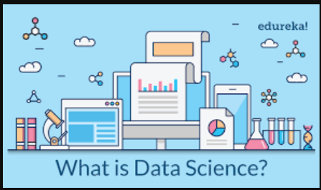

***Why is Data Science important?***

**Data science is important because it combines tools, methods, and technology to generate meaning from data. Modern organizations are inundated with data; there is a proliferation of devices that can automatically collect and store information. Online systems and payment portals capture more data in the fields of e-commerce, medicine, finance, and every other aspect of human life. We have text, audio, video, and image data available in vast quantities.**

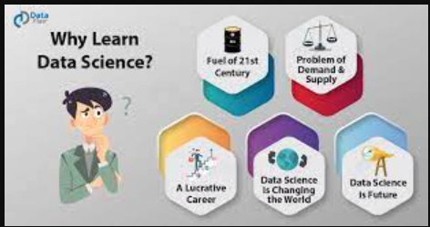

***History of data science***

**While the term data science is not new, the meanings and connotations have changed over time. The word first appeared in the ’60s as an alternative name for statistics. In the late ’90s, computer science professionals formalized the term. A proposed definition for data science saw it as a separate field with three aspects: data design, collection, and analysis. It still took another decade for the term to be used outside of academia.**

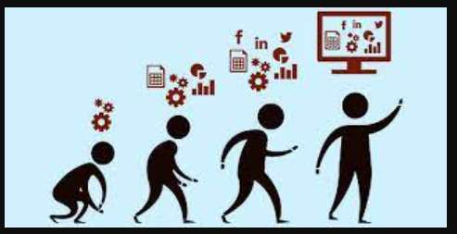

***Future of data science***

**Artificial intelligence and machine learning innovations have made data processing faster and more efficient. Industry demand has created an ecosystem of courses, degrees, and job positions within the field of data science. Because of the cross-functional skillset and expertise required, data science shows strong projected growth over the coming decades.**

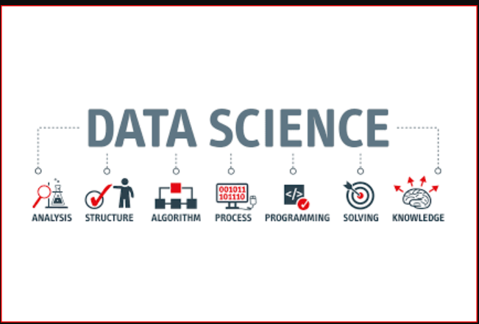

***What is Data Science used for?***

* **Descriptive Analysis**
* **Diagnostic Analysis**
* **Predictive Analysis**
* **Prescriptive Analysis**

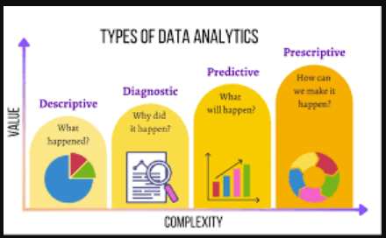

***What is the Data Science Process?***

**A business problem typically initiates the data science process. A data scientist will work with business stakeholders to understand what business needs. Once the problem has been defined, the data scientist may solve it using the OSEMN data science process:**

**O – Obtain Data**

**S – Scrub Data**

**E – Explore Data**

**M – Model Data**

**N – Interpret Results**

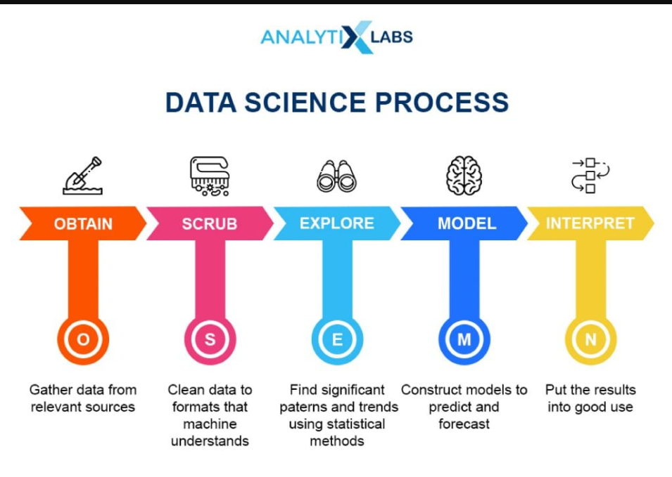

***What are different data science technologies?***

* **Artificial Intelligence**
* **Cloud Computing**
* **Internet of Things**
* **Quantum Computing**

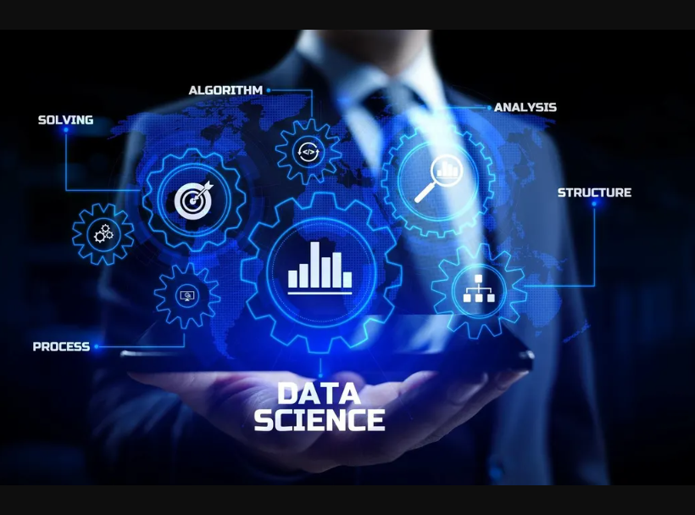

***Source :*** [**https://aws.amazon.com/what-is/data-science/**](https://aws.amazon.com/what-is/data-science/)